# GOVERNMENT COLLEGE OF ENGINEERING [IRTT]

**ERODE: 638 316**



# Electronics and Communication Engineering

**NAAN MUDHALVAN DIGITAL MARKETING ASSIGNMENT**

*BRAND NAME: RAJA TRADERS*

*CATEGORY: COCONUT EXPORT*

NAME : RANJITH KUMAR S

NM ID : 9ECC48F55B2F41D9562488A7CAD7759C

1. Create a blog or website using Blogspot and WordPress. Customize the theme design and post new article with 500 words.

Link: Blog using Blogspot

https://saravananrajatraders.blogspot.com/2023/09/raja-traders-dry-coconut-also-known-as.html

Screenshot:

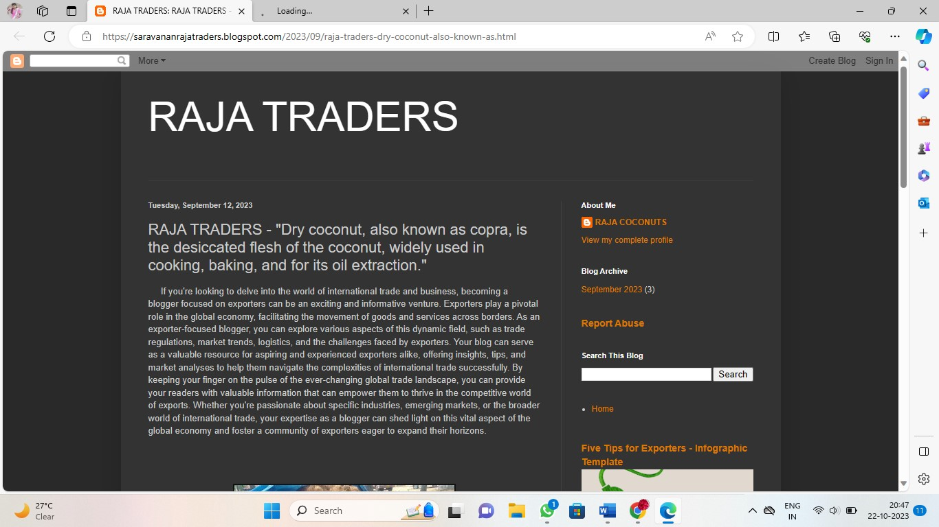

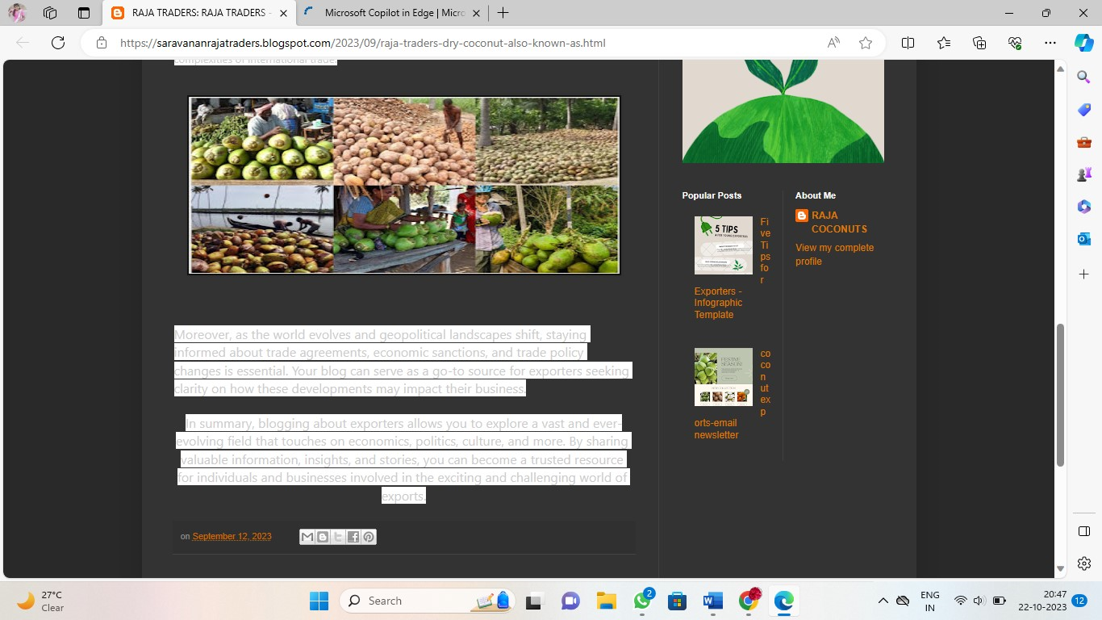

1. Create a New Facebook Business Page and post one social media poster for your brand.

Link: Facebook business page https://www.facebook.com/profile.php?id=61551216658791

Screen shot:

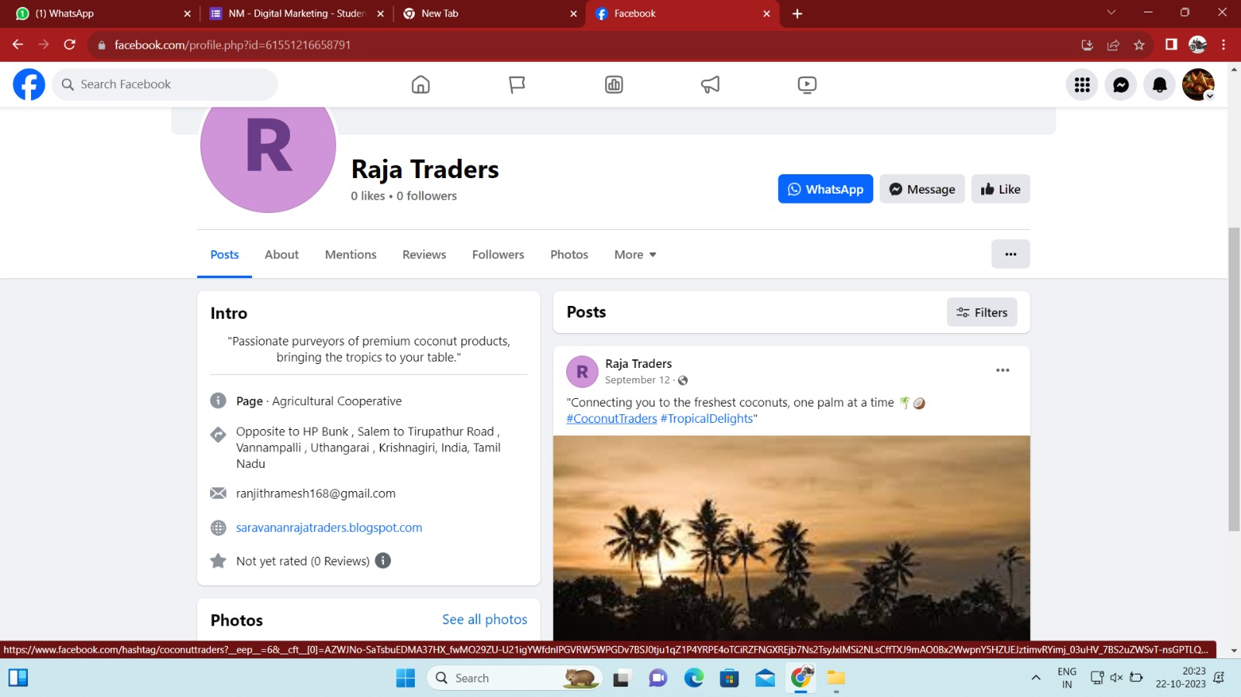

1. Create and design a social media advertisement poster using canva.

Link: Social media advertisement using canva

https://saravananrajatraders.blogspot.com/2023/09/blog-post.html

Screenshot:

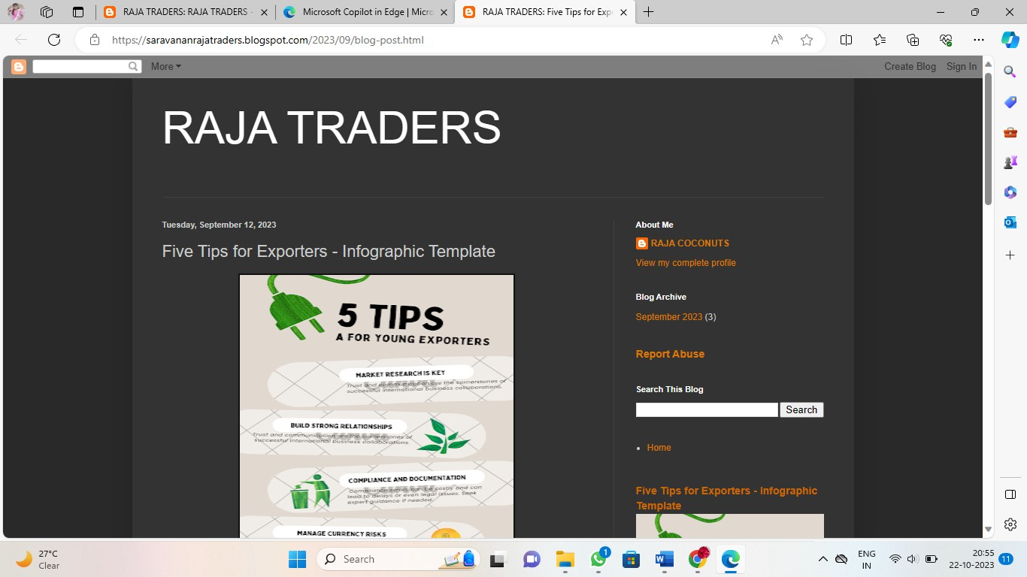

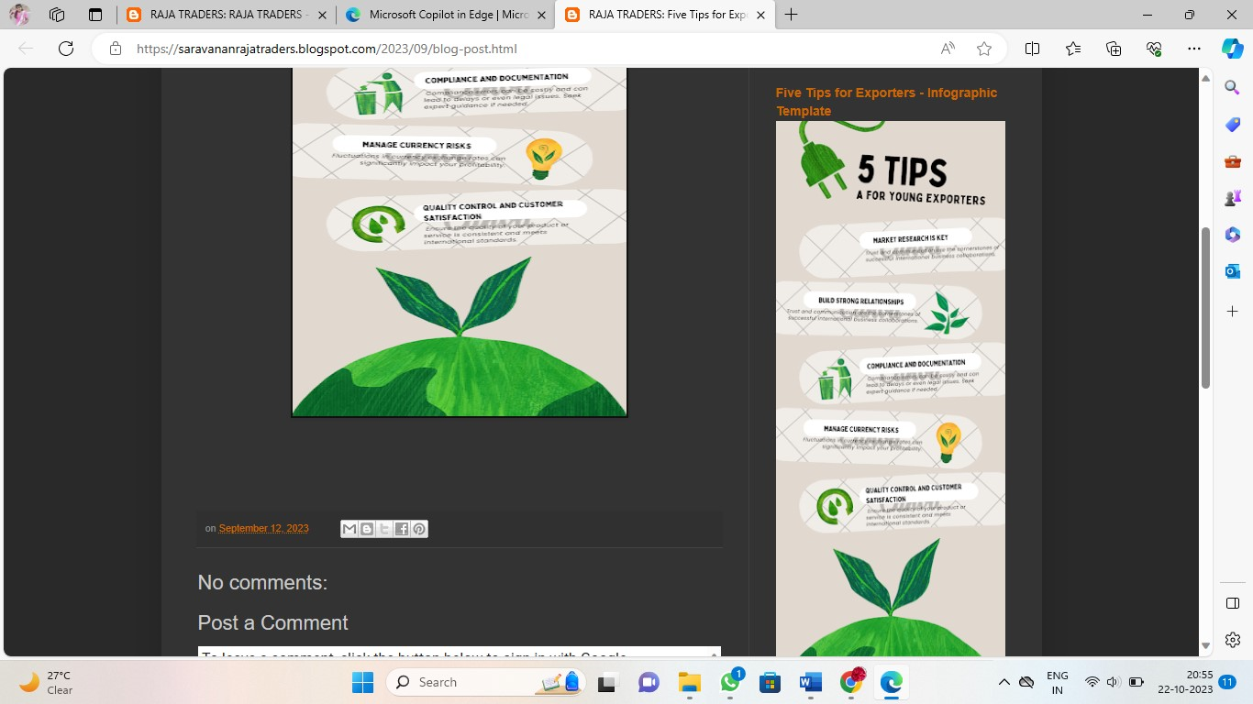

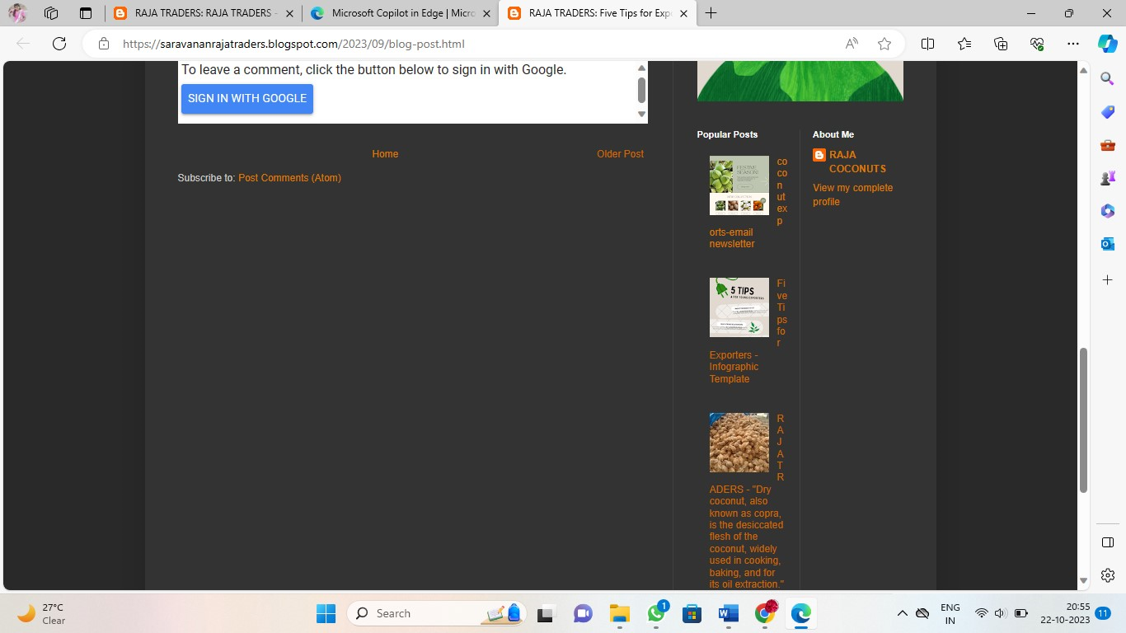

1. Create email newsletter design using MailChimp or canva tool.

Link: Email newsletter design using canva

https://saravananrajatraders.blogspot.com/2023/09/coconut-exports-email-newsletter.html

Screenshot :

